Introduction To Project

“Rapid Avail” is a website or an online platform which will help users to find service professional like a Plumber, CCTV Repair, Electrician, Painter, etc. and book them online. Rapid Avail is the simplest way to hire trusted professionals to help the customers for all their service needs at their door steps.

Admin will add various categories under which service providers will sign up and create an account which will be verified by the admin. After that they will set their tariff. They will be able to view current and previous bookings. They will be able to accept or reject the bookings.

Users will sign up and find the service providers by selecting their area and category. They can book hourly slots of the service providers and will pay by the end of the work. The service provider will not be available for booking at that time by other users, if it is already booked by a user for that particular slot(s). Users can cancel the booking at any time. After cancellation, service provider will be available again for the slot(s) that are cancelled.

We have tried our best to study the existing system and its flaws and then design our project. But as it is well said there is always a scope of improvement. Our project is developed such that it can easily be modified as well as extended in future so as to enhance its capabilities and functionalities.

In future, we can enhance the usability of our project to the customer by providing an additional user interface which will allow the user to view and booked various services available on this website.

PROPOSED SYSTEM

Admin Interface:

Admin can manage the categories, areas, news, resolves the complaints of the user. Check the Service Provider who requested as a Service Provider is genuine or not. If they think the Service Provider is not genuine, in that case they can also reject the request of Service Provider.

Service Provider Interface:

“Rapid Avail” authorizes Service Provider to set tariff per hour for booking. One can change their area and view their bookings done.

User Interface:

“Rapid Avail” provide user to book service according to their flexible time without wasting time in moving outside and finding the service shops, one can book their facility for professionals within a few seconds by selecting category and area. User can also cancel their booking if required. Users can complaint about the Service Provider, if not satisfied. User can also see the latest news about the Website. User can also add the reviews about their experiences. Users can pay the Service Provider after getting services.

Also Users can add reviews for various services, so that other users can read those reviews, so that they come to know about the *Pros* and *Cons* of this website before using it.

OBJECTIVES

* Provide real time information.
* Provide user/visitor/customer interaction with the system.
* Give access to the user/visitor/customer interaction with the system.
* Centralized databases.
* Planned approach.
* Accuracy to the data.
* Reliability.
* No redundancy.
* Immediate retrieval & storage.
* Easy to operate.
* User friendly.

INTRODUCTION TO LANGUAGE

* FRONT-END
* BACK-END

Front End :-> PHP

PHP started out as a small open-source project that evolved as more and more people found out how useful it was. “Rasmus Lerdorf” unleashed the first version of PHP way back in 1994.

PHP is a recursive acronym for “PHP: Hypertext Preprocessor”. PHP is a server-side scripting language that is embedded in HTML. It is used to manage dynamic content, databases, session tracking, even build entire e-commerce sites. It is integrated with a number of popular databases, including MySQL, PostgreSQL, Oracle, Sybase, Informix and Microsoft SQL Server.

PHP is pleasingly zippy in its execution, especially when compiled as an Apache module on the Unix side. The MySQL server, once started, executes even very complex queries with huge result sets in record-setting time. PHP supports a large number of major protocols such as POP3, IMAP and LDAP. PHP4 added support for Java and distributed object architectures (COM and CORBA), making n-tier development a possibility for the first time. PHP syntax is C-Like.

PHP programs run on a web server and serve web pages to visitors on request. One of the key features of PHP is that you can enable PHP code with HTML web pages, making it very easy to create dynamic content quickly. PHP gives you a good idea of its core purpose: to process information and produce Hypertext (HTML) as a result.

PHP is a server-side scripting programming language for building dynamic, interactive websites language which means that PHP scripts, or programs, usually run on a web server. (A good example of client-side scripting language is JavaScript, which commonly runs within a web browser.) PHP is an interpreted language – PHP script is processed by the PHP engine each time it runs.

The process of running a script on a web server looks like this:

* A visitor requests a webpage by clicking a link, or typing the pages URL into browsers address bar. The visitor might also send data to the web server at the same time, either using a form embedded in a webpage.
* The web server recognizes that the requested URL is a PHP script and instructs the PHP engine to process and run the script.
* The script run, and when it finished it usually sends a HTML page to the web browser, which the visitor then sees on their screen.

The interesting stuff happens when a PHP script runs. Because PHP is so flexible, a PHP script can carry out any number of interesting tasks such as:

* Reading and processing the contents of a web form sent by a visitor.
* Reading, writing the creating files on the web server.
* Working with data in a database stored on the web server.
* Grabbing and processing data from other websites and feeds.
* Generating dynamic graphics such as- charts and manipulating photos.

The PHP development team is proud to announce the intermediate release of PHP 5.3.0. This release is a major improvement in the 5.x. series, which includes a large number of new features and bug fixes.

The key features of PHP 5.5 include:

* Support for namespaces.
* Late static binding.
* PHP performs system functions, i.e., from files on a system it can create, open, write, read and close them.
* PHP can handle forms, i.e., gather data from files, save data to a file, through email you can send data, return data to the user.
* You can add, delete, modify elements within your database through PHP.
* Access cookies variables and set cookies.
* Using PHP, you can restrict users to access some pages of your website.
* It can encrypt data.
* PHP supports variable usage without declaring its data type. It will be taken at the time of the execution based on the type of the data it has on its value.

All these key features mean that you can use PHP to create practically any type of dynamic web application you can dream of. Common examples of PHP scripts include:

* Web forums that allow visitors to host messages and discuss topics.
* Search engines that let people to search the contents of a website or database.
* Straw poll scripts that enable visitors to vote a polls and surveys.
* Content management systems and blogs, which enable webmasters to create sites easily with minimal technical knowledge.
* Webmail applications, allowing people to send and receive email using their web browser.
* Online stores, allowing shoppers to purchase products and services over the internet.

Back End :-> MYSQL

MYSQL is a relational DBMS. In MYSQL data is stored in tables rather than in a flat file. MYSQL roots begin in 1979. MYSQL is portable and runs on commercial operating systems and on hardware all the way up to enterprises server.

MYSQL uses the client/server model that is database server (MYSQL) that’s serves (communications) with multiple clients (application programs), where the clients may or may not be on the same computer. It also support SQL, the structured query language, a standardized language used by most modern databases for working the data and administering the database.

MYSQL software is open sources. Open sources means that it is possible for anyone to download MYSQL from the internet, & use & modify the software without paying anything. The MYSQL software uses GPL and GNU (General Public License), to define what you may or may not do with the software in different situations.

MYSQL database server is very fast, reliable & easy to use. MYSQL server was originally developed to handle large databases. Much faster than existing solutions & has been successfully used in highly demanding production environment for several years. Its connectivity, speed & security make MYSQL server highly suited for accessing database on the internet.

MYSQL serves a back end for all kinds & information’s such as email, web images & content, games, log files & soon. The serves can be embedded in applications such as cell phones, electronic devices, public kiosks & more.

MYSQL has many attractive Features to offer:

* Built-in Libraries
* Extensibility
* Relatively Low Cost
* Portability
* Developer Community
* Ease of Learning
* High Performance
* Speed
* Easy to Use
* Query Language Support
* Availability & Cost
* Open Distribution & Source Code

MYSQL has its roots in an in-house (non-SQL) database system. The version 5.1 release, schedule for the second half of 2006, will add important facilities such as an internal scheduler, table partitioning, row based replication and many other significant enhancements.

MYSQL chose to implement its stored programs language within the MYSQL. The MYSQL is a block structured language that includes familiar commands for manipulating variables, implementing conditional execution, performing iterative processing and handling errors.

There are other resources open to you as well and you’ll find that MYSQL has good support.

* The MYSQL reference manual is included in MYSQL distribution and also is available online and in printed form. The reference manual regularly receives good marks in the MYSQL user community. This is important, because the value and good product is diminished if no one can figure out how to use it.
* Technical support contracts, monitoring services and training classes are available from Sun Microsystems.
* There are several active MYSQL mailing lists to which anyone may subscribe. These lists have many helpful participants, including several MYSQL developers.

Tools provided with MYSQL:

* SQL Server: This is the engine that powers MYSQL and provides access to your database.
* Client & Utility Programs: These include an interactive client programs that enables you to enter queries directly and view the results. Several Administrative and Utility Programs are also available that help you to run your site i.e., One allows you to monitor and control the server, other let you to perform Data Backups, check Tables for problems and more.
* A Client Library for writing your own Programs: You can write client programs in C because the library is in C, but the library also can be linked into other language processors, such as PHP to provide the basis for MYSQL interface in those language.

MYSQL is used by many talented and capable people who like writing software to enhance their productivity and who are willing to share that software. The result is that you have access to a variety of third-party tools that make MYSQL easier to use or that extent it reach into areas, such as website development.

## SYSTEM DEVELOPMENT LIFE CYCLE

## System Development life cycle is an organization process of developing and maintain system. Information system is a mechanism that helps people collect, store, organize and use information. Information system is more than storing and retrieving. SDLC is an organized way to build information. System it involves development of candidate system i.e. a newly development system to replace currently existing. For better working the task of designing a system is divided into a series of phase.

## STAGES OF SDLC

## Feasibility study

## System Analysis

## System Design

## Coding

## Testing

## Implementation

## Maintenance

SDLC

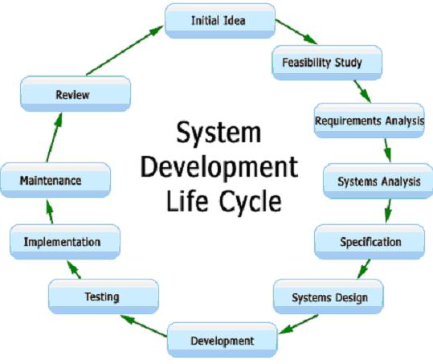

## SYSTEM STUDY

System Study is the first phase of SDLC. System Study is performed to understand the problem which is solved by the proposed system. The problem could be an existing system, developing a complete new automated system or combination of both. This phase is also known as Problem Definition Phase. After completing a System Study, a System proposal is prepared by the System Analyst and place before the management. The proposed System contains the findings of the present System and recommendations to overcome the limitations of present System.

FEASIBILITY STUDY

A Feasibility Study is a test of a system proposal according to its work ability, impact on meet users needs and effective use of resources. On the bases of system study, Feasibility Study takes place. There are the following types of Feasibility Study.

TYPES OF FEASIBILITY:

1. Technical Feasibility :-> It involves to determine whether the system can actually be constructed to solve the problem or not. If includes following question.

* Is the project feasibility within the limits of current technology?
* Does the technology exist at all?
* Is it available within given resources constraints (i.e., budget, schedule)?

1. Operational Feasibility :-> The willingness of management, employees, customers and suppliers to use and support the proposed system comes under the operational feasibility.
2. Economic Feasibility :-> It involves whether the sufficient economic available for developing the system or not. It involves estimating the cost-benefit analysis.

## SYSTEM ANALYSIS

The task of System Analysis is to establish in detail what the proposed system will do (as opposed to how this will be accomplished technologically).

Characteristics of System analysis include:

* Establishing the objectives of the new system, conducting an analysis of its costs and the benefits to be derived from it and outlining the process of system implementation.
* Detailed system analysis must also establish who the system user are, what information they should get and in what from, and how this information will be obtained from the incoming data and from the databases.

SYSTEM DESIGN

The most creative and challenging phase of the system life cycle is system design. The term design describes a final system and the process by which it is developed. It refers to the technical specifications that will be applied in implementing the proposed system. It also includes the construction of program and designing of output, input, code, database and process of the system. During the design phase, the system is designed, to satisfy the requirements identified in the requirements Analysis phase are transformed into a system design document that accurately describes the design of the system and that can be used as an input to system development in the next phase.

## OBJECTIVES:

## Successful completion of the design phase should comprise:

## Transformation of all requirements into detailed specifications covering all aspects of the system.

## Assessment and planning for security risks.

## Approval to progress to the Development Phase.

* GOALS:

The purpose of the design phase is to transform the requirements into complete and detailed system design specifications once the design is approved, the Development Team begins the Development Phase.

CODING

After designing the new system the whole system is required to be converted into computer understandable language. Coding is the process of developing software for the proposed system using some computer programming language. It is an important stage where the defined procedures are transformed into specifications with the help of computer language. This is also called the programming phase in which the programmer convent the program specification in computer instruction, which we refer as programs. These programs coordinate the data movement and control the entire process in a system.

TESTING

Before actually implementation the system into Operations, a test run of the system is done after removing all the errors. In software development project, errors can occur at any stage during development. The main causes of error are:

* Not obtaining the right requirements.
* Not getting the requirement’s right.
* Not translating the requirements in a clear and understandable manner so that programmer implements them properly.

IMPLEMENTATION

After having the user acceptance of the new system developed, the implementation phase begins. Implementation is the stage of project during which theory is turned into practice. During this phase all the programs of the system are loaded into the user’s computer. After coding the system the training of the user starts. Main topics of such type of training are:

1. How to execute the package?
2. How to enter the data?
3. How to process the data?
4. How to take out the reports?

After the users are trained about the computerized system, manual working has to shift from manual to computerized working. The following two strategies are followed for running the system:

## Parallel run

* Pilot run

MAINTENANCE

Maintenance is necessary to eliminate errors in system during its working life and to tune the system to any variations in its working environment. It has been seen that there are always some error found in the system that must be noted and corrected. It also means that review of the system from the time. The review of the system is done for.

## Knowing the full capability of the system.

## Knowing the required changes or the additional requirements.

## Studying the performance.

## SOFTWARE DEVELOPMENT TOOLS

Software Development Tools help the System Analyst to document the System specifications during the designing of the project. The main tools for Software Development are as follows:

* ER-Diagram
* Data Dictionary
* Decision Tree
* Decision Table
* Flowchart
* Data Flow Diagram

1. ER-Diagram: The ER-Model is based on a view of real world that consist of set of objects called entities and relationship among entity sets which are basically a group of similar objects. The relationships between entity sets is represented by a named ER relationships and is of 1:1, 1:M or M:M type which tells the mapping from one entity set to another.

* The ER diagram used for representing ER Model can be easily converted into relations in Relational Model.
* The ER Model is used for the purpose of good database design by the database developer, so to use that data model in various DBMS.
* It is helpful as a problem decomposition tool as it shows the entities and the relationship between those entities.
* It is inherently an iterative process. On later modifications, the entities can be inserted into the model.
* It is very simple and easy to understand by various types of users and designers because specific standards are used for their representations.

1. Data Dictionary: A Data Dictionary defines each term encountered during analysis and design of a new system. Data Dictionary is the structured information of data, which is arranged in particular order (ascending or descending) in case of numeric data and alphabetically in case of character data. There are three items present in Data Dictionary.

* Data Element
* Data Structure
* Data Flow and Data Store
* Data Element: The smallest unit of data which can’t be further decomposed is known as Data Element. For Example- Any number, digit or an alphabet is Data Element.
* Data Structure: Data Elements when clubbed together as a group known as Data Structure. For Example- An array of elements is a Data Structure.
* Data Flow and Data Store: The Data Flow represents the Data Structure in motion whereas Data Stores are the locations where the Data Structures are temporarily stored.

1. Decision Tree: A Decision Tree is a tree like structure that represents the various conditions and the possible actions. Each of its brunches stand for anyone of the logical alternatives and because of Branch Structure it known as a Tree. Decision Tree is easy to construct, update and read. It makes the solution of a problem in a simple way. It is a graphical representation of the conditions, actions and rules found in a Decision Table. It represents the Logical Structure in a horizontal form that resembles a Tree with a Root on the left hand side and Branches to the right which represents each decision.
2. Decision Table: Decision Table is also known as logic table. It is a powerful graphical tool used to analysis and represent complex processing logic. It uses tabular format to represent various actions to be taken for various combinations of conditions. Decision Tables are extremely useful when a program involves a large number of different branches or involves a large number of decisions. As it is easier to draw and change the charts so Decision Tables are used in place of flowcharts. Moreover, the Decision Tables also provide compact documentation. However, due to difficulties involved in designing a chart, they are not considered common tool for program solving by the beginners.
3. Flowchart: A Flowchart is a way of visually presenting the flow of data through an information processing system. A Flowchart may be defined as diagrammatic representation that shows the sequence of operations to be performed within the system to get solution of a problem. Flowchart plays a vital role in the programming of a problem. Flowchart is quite helpful in understanding the logic of complicated and lengthy problems. Once the Flowchart is drawn, it becomes easy to write the problem in any high level language. There are seven basic symbols used to construct Flowcharts.

Symbols Used In Flowcharts:

|  |  |  |
| --- | --- | --- |
| Name of Symbols | Shape of Symbols | Description of Symbols |
| Oval |  | An Oval shaped symbol is used for start and stop. |
| Rectangle |  | Rectangle shaped symbol is used for computational steps. |
| Parallelogram |  | The Parallelogram shaped symbol is used for Input / Output operations. |
| Diamond |  | Diamond shaped symbol used for decision making conditions. |
| Circle |  | Circle shaped symbol is used for decision making connector. |
| Arrow Lines |  | Arrow Lines are used to represent the flow of data. |
| Cylinder |  | Cylindrical shaped symbol represent a data file which is stored on some disk. |

1. Data Flow Diagrams (DFD): Data Flow Diagram is a graphical representation of logic of the problem. It is also known as Bubble Chart or Data Flow Graph. It is most commonly and highly effective technique used in problem analysis. There are following components of Data Flow Diagram:

* Entity: An Entity is the source or destination of data. The source in DFD represents these entities that are outside the context of the system. Entities either provide data to the system or receive data from it. Entities are often represented as Rectangles. Entities are also referred to as Agents, Terminators or Source/Sink.
* Process: A Process is the manipulation of work that transforms data, performing computations, making decisions or directing data flows based on business rules. In other words, a process receives input and generates some output. Process names usually describe the transformation, which can be performed by people or machines. Processes can be drawn as circles or a segmented rectangle on DFD. DFD shows the movement of data through the different transformations or processes in the system.
* Data Store: A Data Store is where a process stores data between processes for later retrieval by that same process or another one. Files and Tables are considered as Data Stores. Data Store names are simple but meaningful, such as “Admin”, “Category”, “Sub-category”. Data Stores are usually drawn as a rectangle with the right hand side or both sides missing and labeled by the name of the Data Storage Area it represents, through different notations do exist.
* Data Flow: Data Flow is the movement of Data between the Entity, the Process and Data Store. Data Flow portrays the interface between the components of the DFD. The flow of data in DFD is named to reflect the nature of data used. Data Flow is represented by an Arrow, where the arrow is annotated with the Data name. All Data Flows in DFD should be labeled. The Arrow Head indicates the direction of Data Flow.

Logical DFD is an implementation independent view of a system, focusing on the flow of data between Process without regard for the specific devices, storage locations or people in the system. In Logical DFD the physical characteristics will not be listed. Physical DFD is an implementation dependent view of the current system, showing what tasks are carried out and how they are performed. Physical characteristics include names of people form and document names or numbers, names of departments, master and transaction file locations and name of procedures. There are four basic symbols used to construct Data Flow Diagrams.

Symbols Used In Data Flow Diagrams:

|  |  |  |
| --- | --- | --- |
| Name of Symbols | Shape of Symbols | Description of Symbols |
| Rectangle |  | A Rectangle represents an Entity. |
| Circle |  | A Circle represents a Process that transforms incoming Data Flow into outgoing Data Flow. |
| Arrow |  | An Arrow identifies Data Flow. It pipeline through which information. |
| Open Rectangle |  | An open Rectangle is used to represent a Data Store. |

Various Levels Of Data Flow Diagram:

Data Flow Diagrams can be expressed as a series of Levels. We begin by making the list of business activities to determine the DFD elements (External Entities, Data Flows, Processes, and Data Store). Next, a context diagram is constructed that shows only a single processes, and associated external entities. The Diagram-0 or Level-0 Diagram, is next, which reveals general Processes and Data Stores. Following the drawing of Level 0 diagrams, Child Diagrams will be drawn for each process illustrates by Level-0 Diagrams. Each Process is then composed into an “Even lower level diagram containing its Sub Processes”. This approach “Then continues on subsequent Sub Processes”, until a necessary and sufficient Level detail is reached which is called the Primitive Process.

* Zero-Level or Context-Level DFD: The outer most level is concerned with how the system interacts with the outside world. This level basically represents the input and output of entire system.
* Level-1 DFD: The basic modules of the system are represented in the phase and how data moves through different modules is shown. The Level-1 DFD provides a high level view of the system that identifies the major processes and data stores.
* Level-2 DFD: The module details are represents in this level. Therefore, detailed Data Flow Diagrams can be drawn with regard to the complexity of system.

DFD 1 (Main Data Flow Diagram):

It is also called context model, represents the entire software element as a single bubble with input and output data indicated by incoming and outgoing arrows, respectively.

**Service Provider**

**Administrator**

Manage Category Authentication of Manage Gallery & Approve/Pending

& Sub Category Service Provider Professional Bookings

Rapid Avail Database

Signup&Login

Choose Category, Sub- Choose & Book

Category & timings Suitable Service

**User**

DFD 2 (Rapid Avail) Manage Category:

**ADMINISTRATOR**

View All Categories

CATEGORY

DFD 3 (Rapid Avail) Manage Sub-Category:

**ADMINISTRATOR**

View all Subcategories

SUBCATEGORY

DFD 4 (Authenticating Service Provider):

**SERVICE PROVIDER**

**ADMINISTRATOR**

SERVICE PROVIDER

DFD 5 ( Book Service Provider):

**USER**

Notify

**SERVICE PROVIDER**

Notify

TESTING

DATABASE TABLES

Administrator Table (admin.sql)

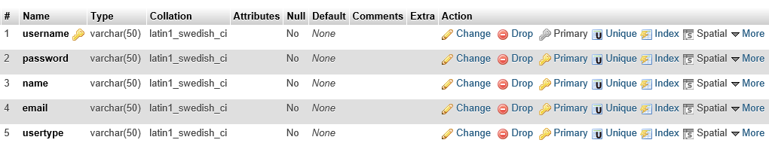

User Table (user.sql)

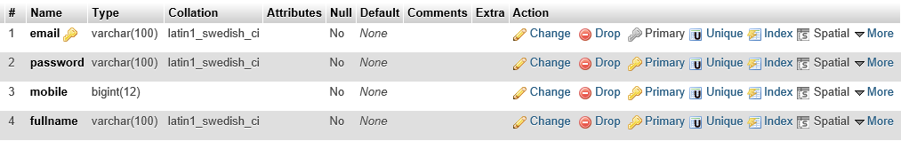

Service Provider Table (serviceprovider.sql)

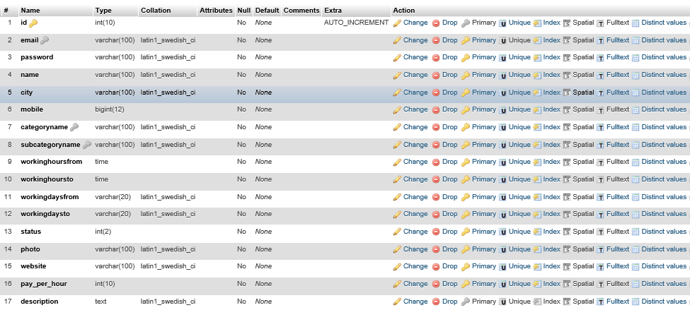

Gallery Table (gallery.sql)

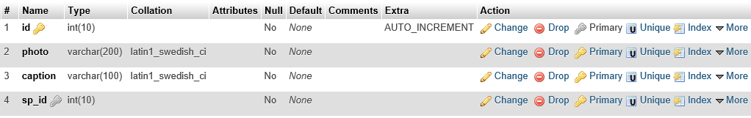

Category Table (category.sql)

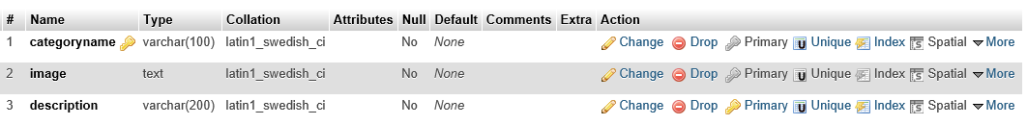

Sub-Category Table (subcategory.sql)

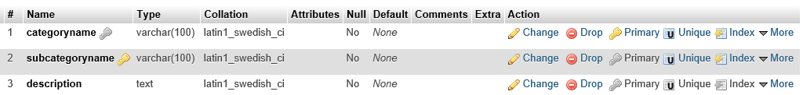

Booking Table (subcategory.sql)

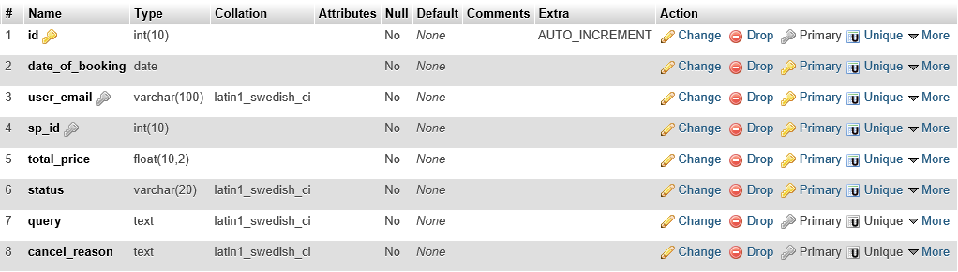

Booking Detail Table (bookingdetail.sql)

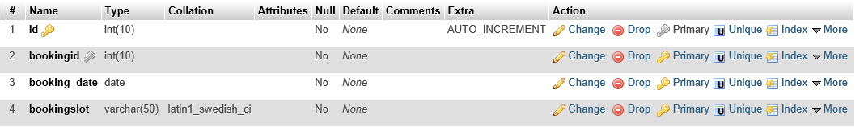

Ratings Table (rating.sql)

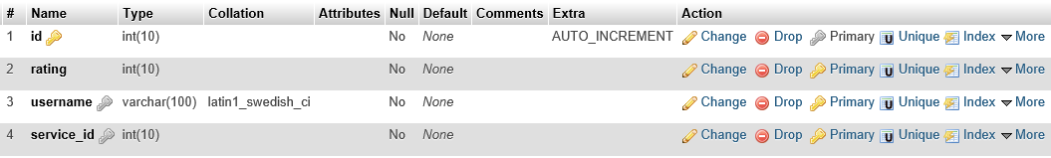

Comments Table (comments.sql)

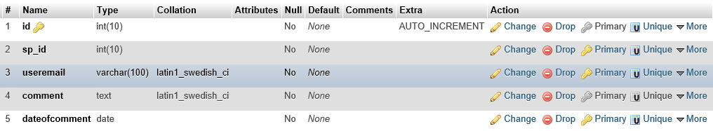

SCREENSHOTS

HOMEPAGE

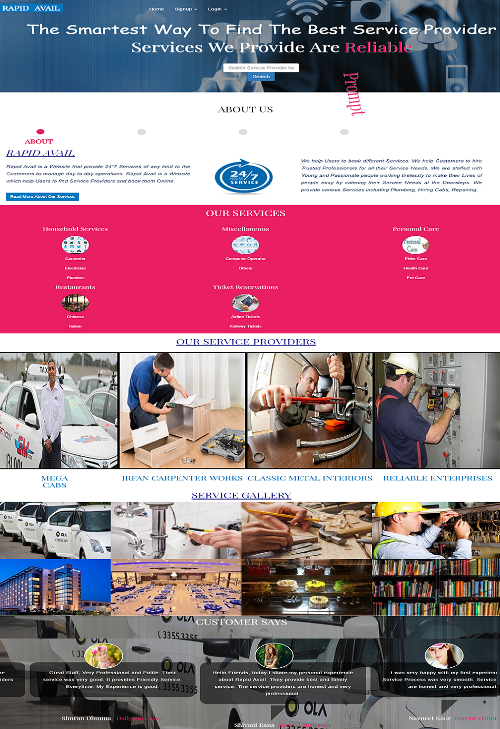

* USER INTERFACE

USER SIGNUP

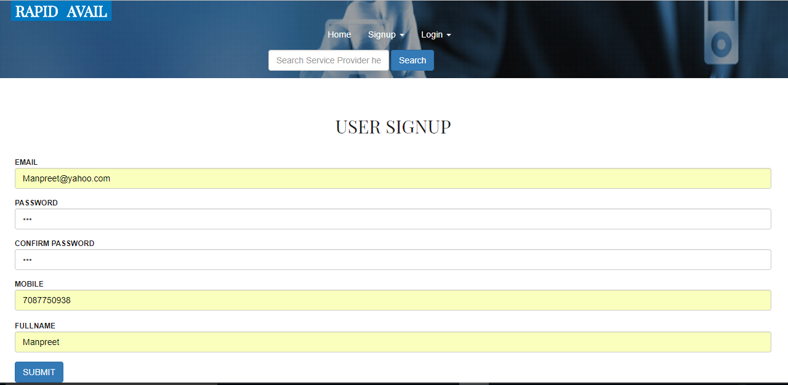

USER LOGIN

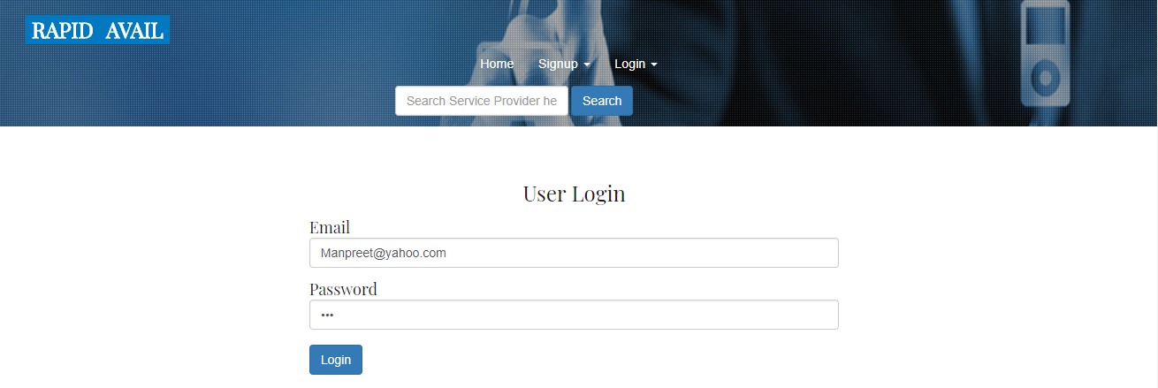

USER HOME

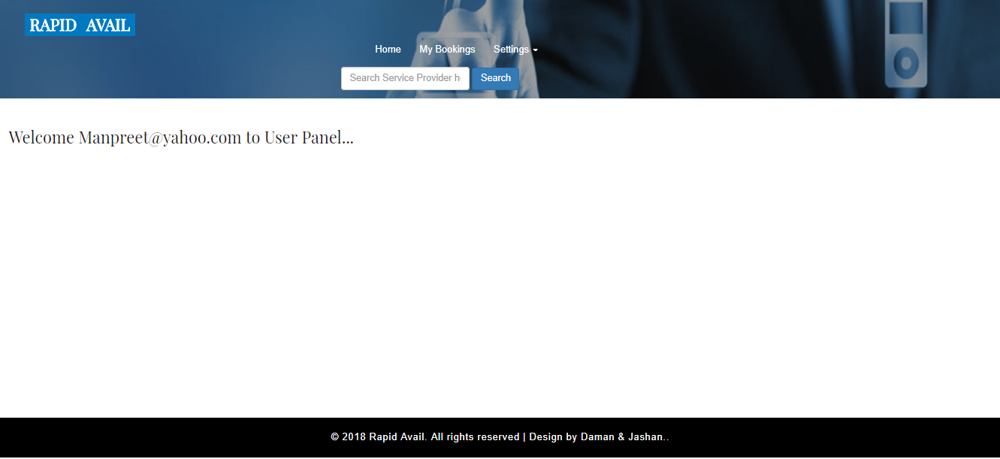

USER CHANGE PASSWORD

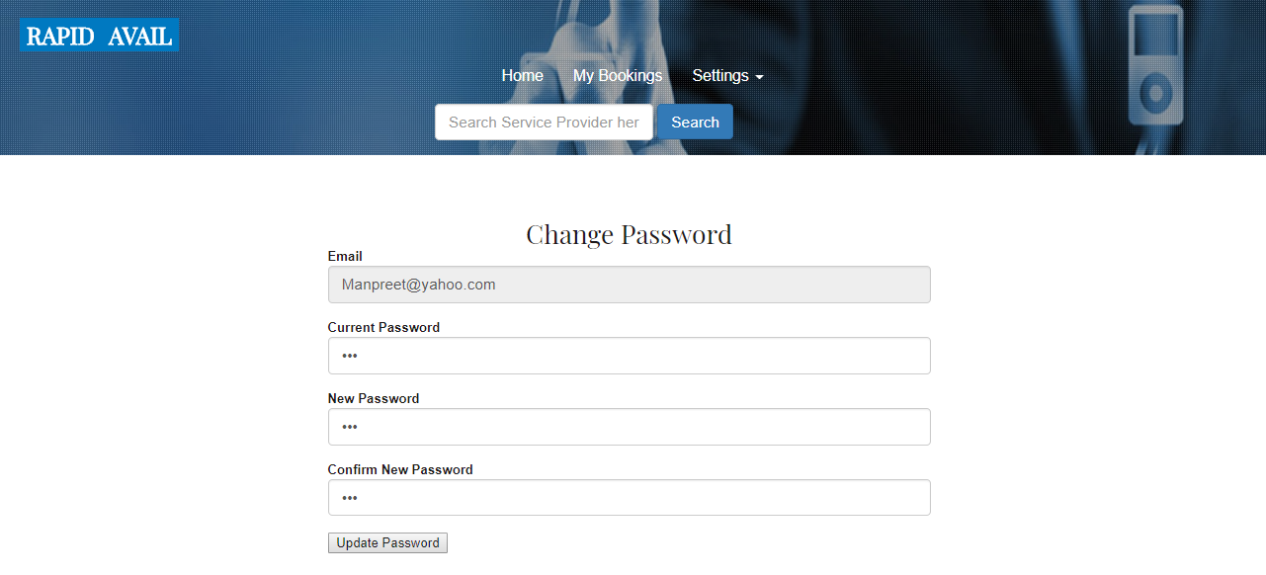

* SERVICE PROVIDER INTERFACE

SERVICE PROVIDER SIGNUP

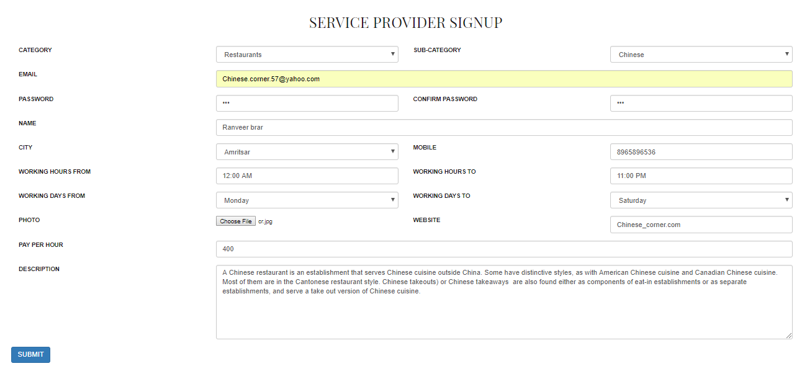

SERVICE PROVIDER LOGIN

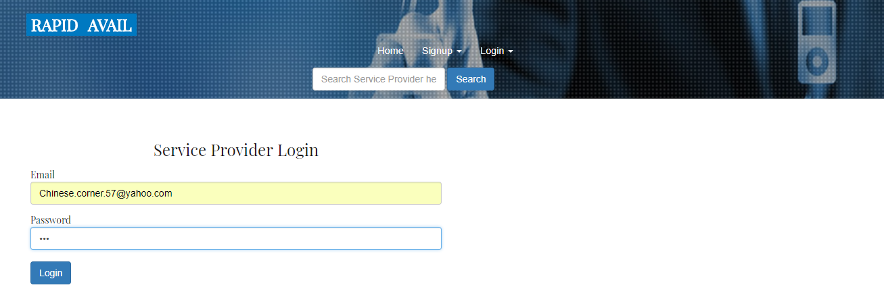

SERVICE PROVIDER HOME

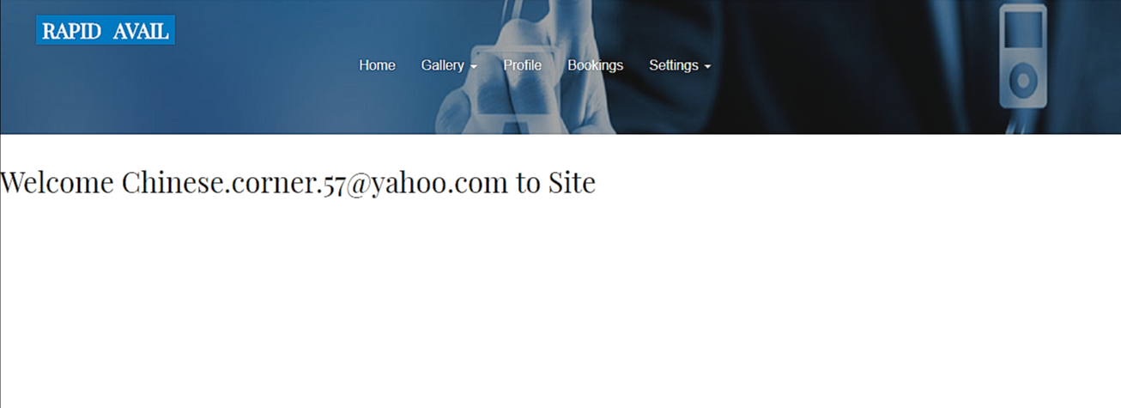

SERVICE PROVIDER CHANGE PASSWORD

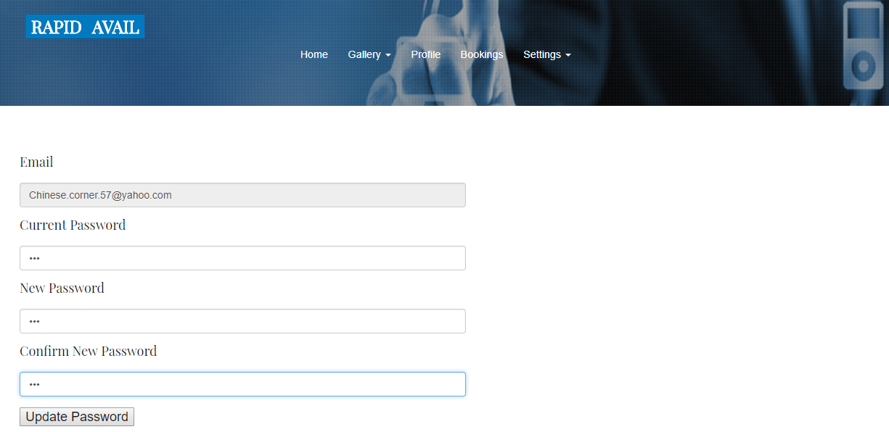

UPDATE SERVICE PROVIDER PROFILE

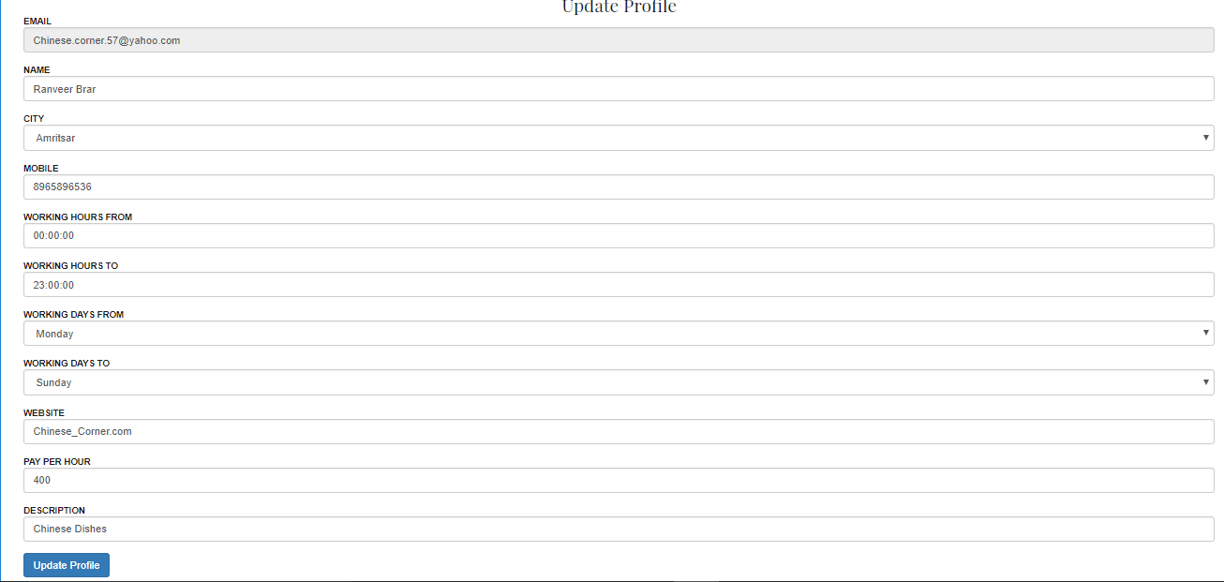

ADD PHOTO TO SERVICE PROVIDER GALLERY

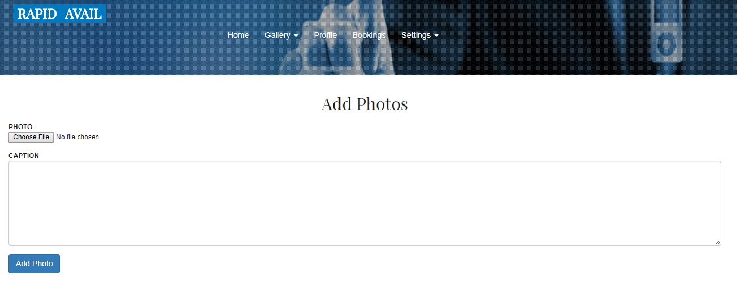

SERVICE PROVIDER BOOKINGS

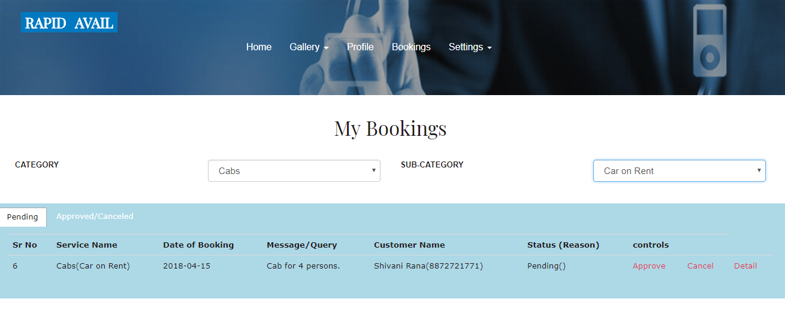

* ADMIN INTERFACE

ADMIN SIGNUP

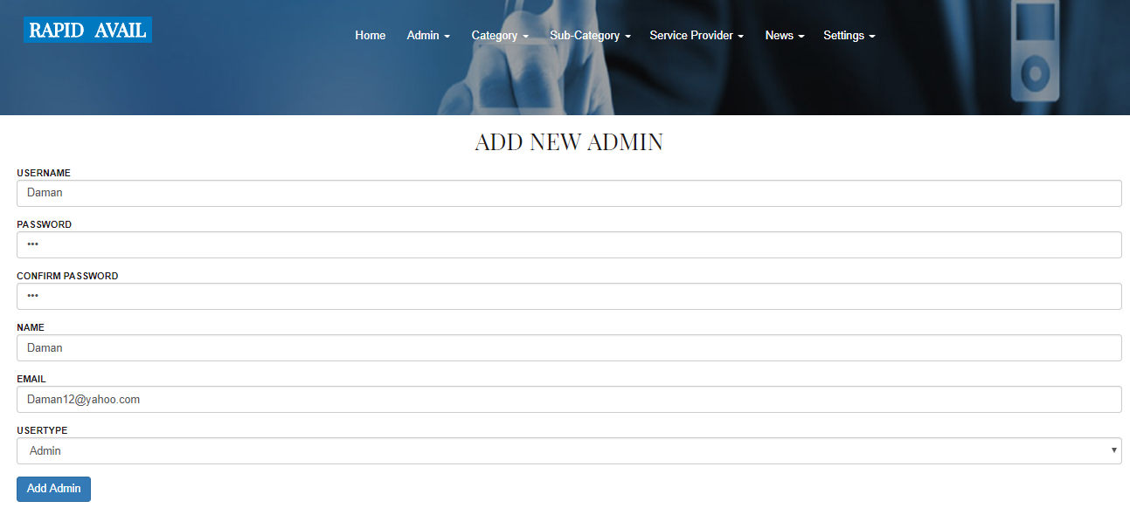

ADMIN LOGIN

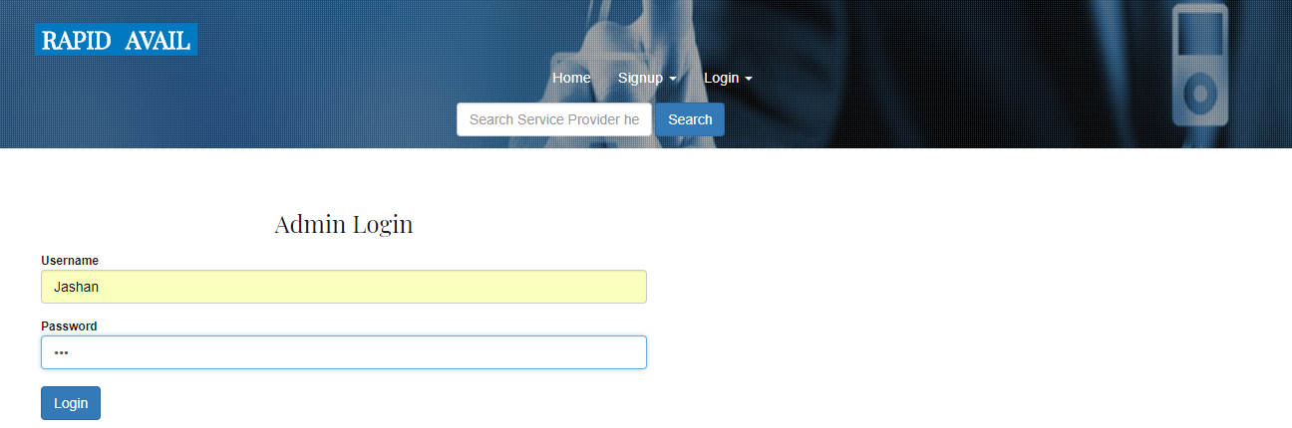

ADMIN HOME

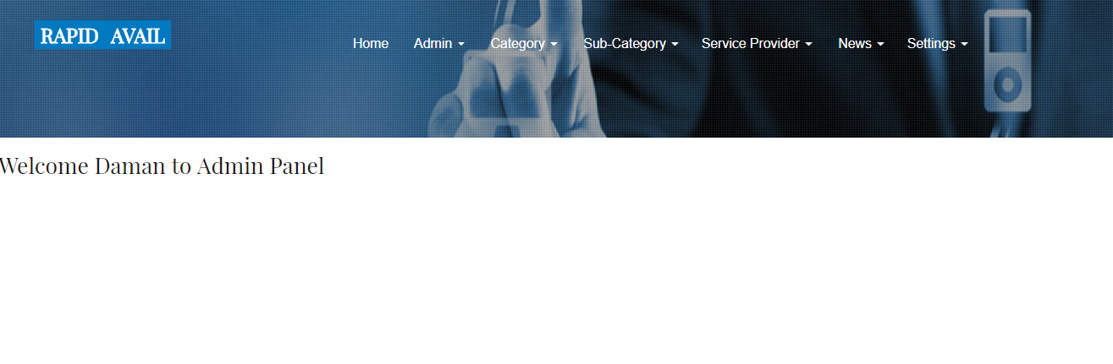

ADMIN CHANGE PASSWORD

ADD CATEGORY

ADD SUB-CATEGORY

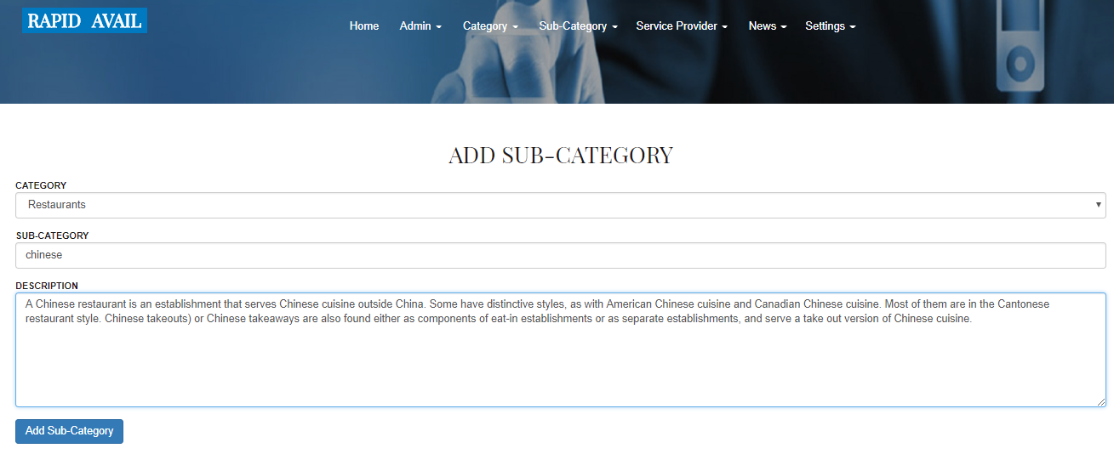

CODING

Index.php (Home Page)

<!doctype html>

<html>

<head>

<meta charset="UTF-8">

<meta name="viewport" content="width=device-width, user-scalable=no, initial-scale=1.0, maximum-scale=1.0, minimum-scale=1.0">

<meta http-equiv="X-UA-Compatible" content="ie=edge">

<title>Document</title>

<?php

include 'headerfile.html';

?>

</head>

<body>

<?php

include "connection.php";

$selcategory ="select * from category";

$resultcategory = mysqli_query($con, $selcategory);

$category= '["';

while($rowcategory = mysqli_fetch_array($resultcategory)) {

$category = $category . $rowcategory[0]. '","';

}

$category = trim($category, '"');

$category = trim($category, ',');

$category = $category. "]";

?>

<script>

$(document).ready(function () {

var availableTags = <?php echo $category; ?>;

//alert(availableTags);

$("#service_provider").autocomplete({source: availableTags});

});

</script>

<script>

function search_service_providers1() {

var service_provider = document.getElementById("service_provider").value;

var xhttp;

xhttp = new XMLHttpRequest();

xhttp.onreadystatechange = function () {

if (this.readyState == 4 && this.status == 200) {

//alert(this.responseText);

document.getElementById("search_service_providers").innerHTML = this.responseText;

}

};

xhttp.open("GET", "search_service_providers.php?q=" + service_provider, true);

xhttp.send();

}

</script>

<div class="banner jarallax">

<div class="agileinfo-dot">

<div class="header">

<div class="container-fluid">

<div class="header-left">

<div class="w3layouts-logo grid__item">

<h1>

<a class="link link--ilin" href="#"><span>Rapid</span><span>Avail</span></a>

</h1>

</div>

</div>

<div class="top-nav">

<nav class="navbar navbar-default">

<div class="navbar-header">

<button type="button" class="navbar-toggle collapsed" data-toggle="collapse" data-target="#bs-example-navbar-collapse-1">

<span class="sr-only">Toggle navigation</span>

<span class="icon-bar"></span>

<span class="icon-bar"></span>

<span class="icon-bar"></span>

</button>

</div>

<!-- Collect the nav links, forms, and other content for toggling -->

<div class="collapse navbar-collapse" id="bs-example-navbar-collapse-1">

<ul class="nav navbar-nav">

<li><a class="active" href="index.php">Home</a></li>

<li class="dropdown"><a href="" class="dropdown-toggle" data-toggle="dropdown">Signup

<span class="caret"></span></a>

<ul class="dropdown-menu">

<li><a href="usersignup.php">User Signup</a></li>

<li><a href="serviceprovidersignup.php">Service Provider Signup</a></li>

</ul>

</li>

<li class="dropdown"><a href="" class="dropdown-toggle" data-toggle="dropdown"> Login <span class="caret"></span></a>

<ul class="dropdown-menu">

<li><a href="userlogin.php">User Login</a></li>

<li><a href="splogin.php">Service Provider Login</a></li>

</ul>

</li>

</ul>

<div class="clearfix"></div>

</div>

</nav>

</div>

</div>

</div>

<div class="agileits-banner-info">

<h3>The Smartest Way To Find The Best Service Provider</h3>

<h2 class="rw-sentence">

<span> Services We Provide Are </span>

<div class="rw-words rw-words-1">

<span>Affordable</span>

<span>Prompt</span>

<span>Reliable</span>

<span>24/7 Available</span>

<span>Accessible</span>

</div>

</h2>

<a>

<form class="form-inline">

<input type="text" name="service_provider" id="service_provider" placeholder="Search Service Provider here" class="form-control">

<input type="button" class="btn btn-primary" value="Search" onclick="search_service_providers1()">

</form>

</a>

</div>

</div>

</div>

<div id="search_service_providers" class="col-md-12">

</div>

<div class="clearfix"></div>

<!-- modal -->

<div class="modal about-modal fade" id="myModal" tabindex="-1" role="dialog">

<div class="modal-dialog" role="document">

<div class="modal-content">

<div class="modal-header">

<button type="button" class="close" data-dismiss="modal" aria-label="Close">

<span aria-hidden ="true"> &times; </span> </button>

<h4 class="modal-title">Rapid Avail</h4>

</div>

<div class="modal-body">

<div class="agileits-w3layouts-info">

<img src="photos/img1.jpg" alt=""/>

<p align="justify" style="color: darkblue">

<i>We provide various other <b>Services</b>, such as, <b>Electrician, Carpenter, Anything on

Hire, Restaurants, Ticket Reservations, Book Hotel Rooms, Personal Care, Gyming </b> and <b>Fitness</b> with many more <b>Services</b>..</i></p>

</div>

</div>

</div>

</div>

</div>

<!-- //modal -->

<!-- tabs -->

<!-- about -->

<div class="demo" id="about">

<div class="container">

<div class="w3ls-heading">

<h3>About Us</h3>

</div>

<div class="horizontalTab" id="horizontalTab">

<ul class="resp-tabs-list list-group">

<li class="list-group-item text-center"></li>

<li class="list-group-item text-center"></li>

<li class="list-group-item text-center"></li>

<li class="list-group-item text-center"></li>

</ul>

<div class="resp-tabs-container">

<!-- section -->

<div class="bhoechie-tab-content active">

<h3 class="title">about</h3>

<div class="services-grids">

<div class="ser-img">

<h2 style="color: darkblue"><u><i> RAPID AVAIL </i></u></h2>

<p align="justify" style="color: #0f2453"><i><b>Rapid Avail</b> is a <b>Website</b> that provide <b>24*7 Services</b> of any kind to the <b>Customers</b> to manage day to day operations. <b>Rapid Avail</b> is a <b>Website</b> which help Users to find <b>Service Providers</b> and book them <b>Online</b>.

</i></p>

<a href="#myModal" data-toggle="modal"> Read More About Our Services</a>

</div>

<div class="ser-img1"><br><br>

<img src="photos/about.png" height="150" width="250" alt=""/>

</div>

<div class="ser-info"><br><br>

<p align="justify" style="color: #0f2453"><i> We help <b>Users</b> to book different <b>Services</b>.

We help <b>Customers</b> to hire Trusted <b>Professionals</b> for all their <b>Service Needs</b>. We are staffed with <b>Young</b> and <b>Passionate</b> people working tirelessly to make their Lives of people easy by catering their <b>Service Needs</b> at the <b>Doorsteps</b>. We provide various <b>Services</b> including <b>Plumbing, Hiring Cabs, Repairing.</b></i></p>

</div>

<div class="clearfix"></div>

</div>

</div>

<!-- section -->

<div class="bhoechie-tab-content">

<h3 class="title ab">Help</h3>

<div class="services-grids">

<div class="col-md-5 menugrid">

<img src="images/banner1.jpg" style="border: solid" height="270" alt=""/>

</div>

<div class="col-md-6 menugrid1 innergrid">

<h3 style="color: darkred"> <b>How to Book a Service ? </b></h3>

<h4><ol style="list-style-type: lower-roman; text-align: justify; color: Black ; font-style: italic">

<li> The Person who wants to book a service should be a user of a website.If a person is not registered on the website then they have to create an account on the website before booking.</li>

<li> After successfull creation, person login to the website.</li>

<li> Choose particular category and sub-category.</li>

<li> Select the timing slots according to your requirements. </li>

<li> Book a service provider.</li></ol></h4>

</div>

<div class="clearfix"></div>

<div class="clearfix"></div>

</div>

<!-- search -->

<div class="bhoechie-tab-content">

<h3 class="title ab1">Why Visit Us?</h3>

<div class="services-grids">

<div class="about-2">

<h3 style="color: #0f2453">&nbsp; We Make Your Life Easier!</h3>

<img src="images/pic1.jpg" style="border: solid; border-color: #0f2453" height="290" width="000" alt=""/>

</div>

<div class="about-info2">

<div class="top-grid">

<br> <div class="col-md-5 grid">

<h3 style="color: #0f2453"> Services 24/7 </h3>

<p style="color: Black;">Anywhere, Anytime Service Bookings with an Online Platform. </p>

</div>

<div class="col-md-5 grid">

<h3 style="color: #0f2453">Productivity</h3>

<p style="color: Black;text-align: justify">Reduce hours and optimize time for managing booking activities.</p>

</div>

<div class="clearfix"></div>

</div>

<div class="bottom-grid">

<div class="col-md-6 grid">

<!-- <i class="fa fa-glass" aria-hidden="true"></i>-->

<h3 style="color: #0f2453">Accessibility</h3>

<p style="color: Black;text-align: justify">Easily access to needed data from a central location wherever you are.</p>

</div>

<div class="col-md-6 grid">

<!-- <i class="fa fa-spoon" aria-hidden="true"></i>-->

<h3 style="color: #0f2453">Simplification</h3>

<p style="color: Black;text-align: justify">Streamline Bookings and Reservation procedures for Customers.</p>

</div>

<div class="clearfix"></div>

</div>

</div>

</div>

</div>

<div class="bhoechie-tab-content">

<h3 class="title ab2">why choose us?</h3>

<div class="services-grids">

<div class="about-2 lastgrid">

<h3 style="color: darkred"><b>Get Instant Access To Reliable and Affordable Services..</b></h3>

<p style="color: Black; text-align: justify"><i>Rapid Avail provide <b>Users</b> to book <b>Services</b> according to their flexible time without wasting any time in moving outside and finding the <b>Service Shops</b>, One can book their Facility for Professionals within a few seconds by selecting <b>Category</b> and <b>Sub-Category</b>. <b>User</b> can also cancel their Bookings if required. <b>Users</b> can also add the <b>Reviews</b> about their <b>Experiences</b>. <b>User</b> can pay the <b>Service Provider</b> after getting <b>Services</b>.

</i></p>

</div>

<div class="about-info2">

<div class="col-md-12 last-grid">

<img src="photos/img1.jpg" style=" border: solid ;border-color: black" height="300" width="900" alt=""/>

</div>

</div>

</div>

</div>

</div>

</div>

</div>

</div>

<!-- tabs js-->

<script src="js/easy-responsive-tabs.js"></script>

<script>

$(document).ready(function () {

$('#horizontalTab').easyResponsiveTabs({ type: 'default', //Types: default, vertical, accordion width: 'auto', //auto or any width like 600px

fit: true, // 100% fit in a container closed: 'accordion', // Start closed if in accordion view activate: function (event) { // Callback function if tab is switched

var $tab = $(this);

var $info = $('#tabInfo');

var $name = $('span', $info);

$name.text($tab.text());

$info.show();

}

});

$('#verticalTab').easyResponsiveTabs({ type: 'vertical', width: 'auto', fit: true });

});

</script>

<!-- //tabs-js -->

<!-- //tabs --> <!-- //about -->

<!-- services -->

<div class="services" id="services">

<div class="container">

<div class="ser-top wthree-3 wow fadeInDown w3-service-head">

<h3>Our Services</h3>

</div>

<div class="w3-service-grids set-6">

<?php

$qr1 = "Select * from category";

$res1 = mysqli_query($con, $qr1);

while ($row1 = mysqli_fetch_array($res1)) {

?>

<div style="height: 300px" class="col-md-4 services-w3-grid1 ser-left icon1 hi-icon-wrap hi-icon-effect-6">

<h4><?php echo $row1[0] ?></h4><br>

<i class=""><img src="<?php echo $row1[1] ?>" class="img-circle" width="70" height="70"></i>

<ol class="nav nav-stack">

<?php

$sub_cat = "select * from subcategory WHERE categoryname='$row1[0]'";

$sub_cat_result = mysqli_query($con, $sub_cat);

while ($sub_cat_row = mysqli_fetch_array($sub_cat_result)) {

?>

<li>

<a href="search_service_providers.php?cat=<?php echo $sub_cat_row[0] ?> &subcat= <?php echo $sub_cat_row[1] ?>"><?php echo $sub_cat_row[1] ?></a>

</li>

<?php

}

?>

</ol>

</div>

<?php

}

?>

</div>

<div class="clearfix"></div>

</div>

</div>

</div>

<!-- /services -->

<!-- our service providers-->

<div class="ourchefs" id="chefs">

<div class="container">

<div class="w3ls-heading">

<h3 style="color: darkblue"><u>Our Service Providers</u></h3>

</div>

<div class="w3layouts_gallery_grids">

<div class="col-md-3 w3layouts_gallery_grid">

<a href="images/sp1.png" class="lsb-preview" data-lsb-group="header">

<div class="w3layouts_news_grid">

<img src="images/sp1.png" alt=" " style=" border: solid; border-color: black;" class="img-responsive">

<div class="w3layouts_news_grid_pos" style="padding-top:100px;">

<div class="wthree_text"><h3>Taxi Driver</h3>

</div>

</div>

</div>

</a>

<div class="chef"> <h3 class="text-center">Mega<br>Cabs</h3></div>

</div>

</div>

<div class="w3layouts_gallery_grids">

<div class="col-md-3 w3layouts_gallery_grid">

<a href="images/sp2.jpg" class="lsb-preview" data-lsb-group="header">

<div class="w3layouts_news_grid">

<img src="images/sp2.jpg" alt=" " style=" border: solid; border-color: black;" class="img-responsive">

<div class="w3layouts_news_grid_pos" style="padding-top:100px;">

<div class="wthree_text"><h3>Carpenter</h3>

</div>

</div>

</div>

</a>

<div class="chef"> <h3 class="text-center">Irfan Carpenter Works</h3></div>

</div>

</div>

<div class="w3layouts_gallery_grids">

<div class="col-md-3 w3layouts_gallery_grid">

<a href="images/sp4.jpg" class="lsb-preview" data-lsb-group="header">

<div class="w3layouts_news_grid">

<img src="images/sp4.jpg" alt=" " style=" border: solid; border-color: black;" class="img-responsive">

<div class="w3layouts_news_grid_pos" style="padding-top:100px;">

<div class="wthree_text"><h3>Plumber</h3>

</div>

</div>

</div>

</a>

<div class="chef"> <h3 class="text-center">Classic Metal Interiors</h3></div>

</div>

</div>

<div class="w3layouts_gallery_grids">

<div class="col-md-3 w3layouts_gallery_grid">

<a href="images/sp3.jpg" class="lsb-preview" data-lsb-group="header">

<div class="w3layouts_news_grid">

<img src="images/sp3.jpg" alt=" " style=" border: solid; border-color: black;" class="img-responsive">

<div class="w3layouts_news_grid_pos" style="padding-top:100px;">

<div class="wthree_text"><h3>Electrician</h3>

</div>

</div>

</div>

</a>

<div class="chef"> <h3 class="text-center">Reliable Enterprises</h3></div>

</div>

</div>

</div>

</div>

<!-- //our service providers-->

<!-- gallery -->

<div class="gallery" id="gallery">

<div class="agileits_w3layouts_head">

<h3 style="color: darkblue"><u>Service Gallery</u></h3>

</div>

<div class="w3layouts_gallery_grids">

<div class="col-md-3 w3layouts_gallery_grid">

<a href="images/p12.jpg" class="lsb-preview" data-lsb-group="header">

<div class="w3layouts_news_grid">

<img src="images/p12.jpg" alt=" " class="img-responsive">

<div class="w3layouts_news_grid_pos">

<div class="wthree_text"><h3>CABS</h3></div>

</div>

</div>

</a>

</div>

<div class="col-md-3 w3layouts_gallery_grid">

<a href="images/p8.jpg" class="lsb-preview" data-lsb-group="header">

<div class="w3layouts_news_grid">

<img src="images/p8.jpg" alt=" " class="img-responsive">

<div class="w3layouts_news_grid_pos">

<div class="wthree_text"><h3>PLUMBER</h3></div>

</div>

</div>

</a>

</div>

<div class="col-md-3 w3layouts_gallery_grid">

<a href="images/p9.jpg" class="lsb-preview" data-lsb-group="header">

<div class="w3layouts_news_grid">

<img src="images/p9.jpg" alt=" " class="img-responsive">

<div class="w3layouts_news_grid_pos">

<div class="wthree_text"><h3>CARPENTER</h3></div>

</div>

</div>

</a>

</div>

<div class="col-md-3 w3layouts_gallery_grid">

<a href="images/p10.jpg" class="lsb-preview" data-lsb-group="header">

<div class="w3layouts_news_grid">

<img src="images/p10.jpg" alt=" " class="img-responsive">

<div class="w3layouts_news_grid_pos">

<div class="wthree_text"><h3>ELECTRICIAN</h3></div>

</div>

</div>

</a>

</div>

<div class="col-md-3 w3layouts_gallery_grid">

<a href="images/p2.jpg" class="lsb-preview" data-lsb-group="header">

<div class="w3layouts_news_grid">

<img src="images/p2.jpg" alt=" " class="img-responsive">

<div class="w3layouts_news_grid_pos">

<div class="wthree_text"><h3>HOTELS</h3></div>

</div>

</div>

</a>

</div>

<div class="col-md-3 w3layouts_gallery_grid">

<a href="images/p5.jpg" class="lsb-preview" data-lsb-group="header">

<div class="w3layouts_news_grid">

<img src="images/p5.jpg" alt=" " class="img-responsive">

<div class="w3layouts_news_grid_pos">

<div class="wthree_text"><h3>BANQUET HAllS</h3></div>

</div>

</div>

</a>

</div>

<div class="col-md-3 w3layouts_gallery_grid">

<a href="images/p13.jpg" class="lsb-preview" data-lsb-group="header">

<div class="w3layouts_news_grid">

<img src="images/p13.jpg" alt=" " class="img-responsive">

<div class="w3layouts_news_grid_pos">

<div class="wthree_text"><h3>BAKERY</h3></div>

</div>

</div>

</a>

</div>

<div class="col-md-3 w3layouts_gallery_grid">

<a href="images/p1.jpg" class="lsb-preview" data-lsb-group="header">

<div class="w3layouts_news_grid">

<img src="images/p1.jpg" alt=" " class="img-responsive">

<div class="w3layouts_news_grid_pos">

<div class="wthree_text"><h3>EDUCATION</h3></div>

</div>

</div>

</a>

</div>

<div class="col-md-3 w3layouts_gallery_grid">

<div class="w3layouts_news_grid">

<img src="images/p6.jpg" alt=" " class="img-responsive">

<div class="w3layouts_news_grid_pos">

<div class="wthree_text"><h3>GROCERY</h3></div>

</div>

</div>

</a>

</div>

<div class="col-md-3 w3layouts_gallery_grid">

<a href="images/p4.jpg" class="lsb-preview" data-lsb-group="header">

<div class="w3layouts_news_grid">

<img src="images/p4.jpg" alt=" " class="img-responsive">

<div class="w3layouts_news_grid_pos">

<div class="wthree_text"><h3>PERSONAL CARE</h3></div>

</div>

</div>

</a>

</div>

<div class="col-md-3 w3layouts_gallery_grid">

<a href="images/p7.jpg" class="lsb-preview" data-lsb-group="header">

<div class="w3layouts_news_grid">

<img src="images/p7.jpg" alt=" " class="img-responsive">

<div class="w3layouts_news_grid_pos">

<div class="wthree_text"><h3>MEDICINE</h3></div>

</div>

</div>

</a>

</div>

<div class="col-md-3 w3layouts_gallery_grid">

<a href="images/p11.jpg" class="lsb-preview" data-lsb-group="header">

<div class="w3layouts_news_grid">

<img src="images/p11.jpg" alt=" " class="img-responsive">

<div class="w3layouts_news_grid_pos">

<div class="wthree_text"><h3>TICKETS</h3></div>

</div>

</div>

</a>

</div>

<div class="clearfix"></div>

</div>

</div>

<!-- //gallery -->

<!-- gallery js -->

<script src="js/lsb.min.js"></script>

<script>

$(window).load(function () {

$.fn.lightspeedBox();

});

</script>

<!-- //gallery js -->

<!-- customer -->

<div class="customer jarallax" id="customer">

<div class="agileinfo-dot">

<div class="container">

<h3>Customer Says</h3>

<div class="customer-grids">

<ul id="flexiselDemo1">

<li>

<div class="customer-grid">

<p> Great Staff, Very Professional and Polite. Their service was very good. It provides Friendly Service. Everytime, My Experience is good. </p>

<h4>Simran Dhunna &nbsp; <span>Daily customer</span></h4>

</div>

<div class="client-img">

<img src="images/u1.jpg" alt=""/>

</div>

</li>

<li>

<div class="customer-grid">

<p> Hello Friends, today I share my personal experience about Rapid Avail. They provide best and timely service. The service providers are honest and very professional. </p>

<h4>Shivani Rana &nbsp;<span>Special customer</span></h4>

</div>

<div class="client-img">

<img src="images/u2.jpg" alt=""/>

</div>

</li>

<li>

<div class="customer-grid">

<p>I was very happy with my first experience. The Service Process was very smooth. Service Providers are honest and very professional. </p>

<h4>Navneet Kaur &nbsp; <span>Recent visitor</span></h4>

</div>

<div class="client-img">

<img src="images/u3.jpg" alt=""/>

</div>

</li>

</ul>

<script type="text/javascript">

$(window).load(function () {

$("#flexiselDemo1").flexisel({visibleItems: 3, animationSpeed: 1000, autoPlay: true, autoPlaySpeed: 3000, pauseOnHover: true, enableResponsiveBreakpoints: true, responsiveBreakpoints: { portrait: { changePoint: 480, visibleItems: 1 }, landscape: { changePoint: 640, visibleItems: 3 }, tablet: { changePoint: 768, visibleItems: 3 } } });

});

</script>

<script type="text/javascript" src="js/jquery.flexisel.js"></script>

</div>

</div>

</div>

</div>

<!-- //customer -->

<!-- map -->

<div class="map">

<iframesrc="https://www.google.com/maps/embed?pb=!1m18!1m12!1m3!1d3396.746592841256!2d74.88082921476328!3d31.640787981329996!2m3!1f0!2f0!3f0!3m2!1i1024!2i768!4f13.1!3m3!1m2!1s0x3919635a87253d69%3A0xa18497d21cc62ff!2sS.S.S.S.+College+Of+Commerce+For+Women!5e0!3m2!1sen!2sin!4v1520934637600"> </iframe>

<div class="agile_map_grid">

<div class="agile_map_grid1">

<h3>Contact Info</h3>

<ul>

<li><i class="fa fa-map-marker" aria-hidden="true"></i><span>Address :</span>40, Gurnam Nagar, Amritsar.. </li>

<li> <i class="fa fa-envelope" aria-hidden="true"> </i> <span> Email : </span>

<a href = “<mailto:damanpreetkaur51@yahoo.com>” > damanpreetkaur51@yahoo.com </a> </li>

<li><i class="fa fa-phone" aria-hidden="true"></i><span>call us :</span>+91 183 22221683</li>

</ul>

</div>

</div>

</div>

<!-- //map -->

<!-- footer -->

<div class="footer">

<div class="col-md-12 footer-left">

<h3>Rapid Avail</h3>

<p align="justify"> Rapid Avail is the smartest way to find the best Service Provider. You can get instant access to Reliable and Affordable Services. </p>

<p align="justify"> We are sure-shot destination for your Service Needs. </p>

</div>

<div class="clearfix"></div>

</div>

<!-- //footer -->

<?php

include "footer.php";

?>

</body>

</html>

Usersignup.php (Add New User Page)

<!doctype html>

<html lang="en">

<head>

<meta charset="UTF-8">

<meta name="viewport" content="width=device-width, user-scalable=no, initial-scale=1.0, maximum-scale=1.0, minimum-scale=1.0">

<meta http-equiv="X-UA-Compatible" content="ie=edge">

<title>Add New User</title>

</head>

<body>

<?php

include "publicheader.php";

?>

<div class="container">

<div class="col-md-12 col-md-offset">

<form action="signupaction.php" method="post">

<h2 align="center">USER SIGNUP</h2>

<div class="form-group">

<label> EMAIL </label>

<input type="text" name="tbemail" data-rule-required="true" data-msg-required="Enter email id" class="form-control" data-rule-email="true" data-msg-email="invalid email address">

</div>

<div class="form-group">

<label> PASSWORD </label>

<input type="password" name="tbpass" id="tbpass" data-rule-required="true" data-msg-required="Enter password" class="form-control">

</div>

<div class="form-group">

<label> CONFIRM PASSWORD </label>

<input type="password" name="tbcpass" data-rule-equalto="#tbpass" data-msg-equalto="password and confirm password not match" data-rule-required="true" data-msg-required="Enter confirm password" class="form-control">

</div>

<div>

<label> MOBILE </label>

<input type="text" name="tbmob" class="form-control" data-rule-required="true" data-msg-required="Enter Mobile Number">

</div><br>

<div class="form-group">

<label> FULLNAME </label>

<input type="text" name="tbname" data-rule-required="true" data-msg-required="Enter full name" class="form-control">

</div>

<div class="form-group">

<input type="submit" value="SUBMIT" class="btn btn-primary">

</div>

</form>

</div>

</div>

<?php

include "footer.php";

?>

</body>

</html>

Userlogin.php (User Login Page)

<!doctype html>

<html lang="en">

<head>

<meta charset="UTF-8">

<meta name = "viewport" content = "width=device-width, user-scalable = no, initial-scale=1.0, maximum-scale=1.0, minimum-scale=1.0">

<meta http-equiv="X-UA-Compatible" content="ie=edge">

<title>login</title>

</head>

<body>

<?php

include "publicheader.php";

?>

<div class="container" style="min-height:430px;">

<div class="col-md-6 col-md-offset-3">

<form action="userloginaction.php" method="post" id="form" class="frm">

<h3 align="center">User Login</h3><br>

<div class="form-group">

<label><h4>Email</h4></label>

<br><input type="text" name="tbemail" data-rule-required="true" data-msg-required="Enter email id" class="form-control" data-rule-email="true" data-msg-email="invalid email address">

</div>

<div>

<label><h4>Password</h4></label>

<br> <input type = "password" name = "tbpass" id = "tbpass" data-rule-required = "true" data-msg-reuired="Enter password" class="form-control">

</div>

<div class="form-group">

<input type="submit" value="Login" class="btn btn-primary">

<?php

if (isset($_REQUEST["msg"]))

{

if($_REQUEST["msg"]==1)

{

echo "<div class='alert alert-danger'>

<strong> Invalid email and password </strong> </div>";

} } ?>

</div>

</form>

</div>

</div>

<?php

include "footer.php";

?>

</body>

</html>

Serviceprovidersignup.php (Add Service Provider)

<?php include("connection.php"); ?>

<!doctype html>

<html lang="en">

<head>

<meta charset="UTF-8">

<meta name = "viewport" content = "width=device-width, user-scalable = no, initial-scale=1.0, maximum-scale=1.0, minimum-scale=1.0">

<meta http-equiv="X-UA-Compatible" content="ie=edge">

<title>Service Provider Signup</title>

</head>

<body>

<?php include "publicheader.php"; ?>

<div class="container">

<div class="col-md-12 col-md-offset">

<form action = "spsignupaction.php" method = "post" class = "form-horizontal" enctype="multipart/form-data">

<h2 align="center">SERVICE PROVIDER SIGNUP</h2><br><br>

<div class="form-group">

<label class="col-md-3">CATEGORY</label>

<div class = "col-md-3"> <select name = "tbcategoryname" data-rule-required = "true" onchange = "showCategories(this.value)" data-msg-required = "select type" class = "form-control">

<option value="">Select Category</option>

<?php

$cat = "select * from category";

$cat_result = mysqli_query($con, $cat);

while ($cat_row = mysqli_fetch_array($cat_result)) {

?>

<option><?php echo $cat_row[0]; ?></option>

<?php } ?>

</select> </div>

<label class="col-md-3">SUB-CATEGORY</label>

<div class = "col-md-3"> <select name = "tbsubcategoryname" id = "subcategory" data-rule-required = "true" data-msg-required = "select type"

class = "form-control">

<option value="">Select Sub-Category</option>

</select></div>

</div>

<div class="form-group">

<label class="col-md-3">EMAIL</label>

<div class = "col-md-9"> <input type = "text" name = "email" data-rule-required = "true" data-msg-required = "Enter email id" class = "form-control" data-rule-email="true" data-msg-email="invalid email address"></div>

</div>

<div class="form-group">

<label class="col-md-3">PASSWORD</label>

<div class = "col-md-3"> <input type = "password" name = "password" id = "password" data-rule-required="true" data-msg-required="Enter password" class="form-control"></div>

<label class="col-md-3">CONFIRM PASSWORD</label>

<div class="col-md-3"> <input type="password" name="cpassword" data-rule-equalto="true" data-rule-equalto="#password" data-msg-equalto="Password and confirm password not match" data-rule-required="true" data-msg-required="Enter confirm password" class="form-control"></div>

</div>

<div class="form-group">

<label class="col-md-3">NAME</label>

<div class="col-md-9"> <input type = "text" name = "name" data-rule-required = "true" data-msg-required = "Enter name" class = "form-control"> </div>

</div>

<div class="form-group">

<label class="col-md-3">CITY</label>

<div class="col-md-3"><select name="city" class="form-control" data-rule-required="true" data-msg-required="Select City">

<option value="">Select City</option>

<option value="Amritsar">Amritsar</option>

<option value="Bathinda">Bathinda</option>

<option value="Jalandhar">Jalandhar</option>

<option value="Ludhiana">Ludhiana</option>

<option value="Patiala">Patiala</option>

</select></div>

<label class="col-md-3">MOBILE</label>

<div class="col-md-3"><input type="text" name="mobile" data-rule-number="true" data-msg-number="Invalid Mobile No." minlength="10" maxlength="12" data-rule-required="true" data-msg-required="Enter Mobile Number" class="form-control"></div>

</div>

<div class="form-group">

<label class="col-md-3">WORKING HOURS FROM</label>

<div class="col-md-3"> <input type = "time" name = "whfrom" class = "form-control" data-rule-required="true" data-msg-required="Enter Working Hours From"></div>

<label class="col-md-3">WORKING HOURS TO</label>

<div class="col-md-3"><input type="time" name="whto" class="form-control" data-rule-required="true" data-msg-required="Enter Working Hours To"></div>

</div>

<div class="form-group">

<label class="col-md-3">WORKING DAYS FROM</label>

<div class="col-md-3"><select name="wdfrom" class="form-control" data-rule-required="true" data-msg-required="Enter Working Days From">

<option value="">Select Day</option>

<option value="Sunday">Sunday</option>

<option value="Monday">Monday</option>

<option value="Tuesday">Tuesday</option>

<option value="Wednesday">Wednesday</option>

<option value="Thursday">Thursday</option>

<option value="Friday">Friday</option>

<option value="Saturday">Saturday</option>

</select></div>

<label class="col-md-3">WORKING DAYS TO</label>

<div class="col-md-3"><select name="wdto" class="form-control" data-rule-required="true" data-msg-required="Enter Working Days To">

<option value="">Select Day</option>

<option value="Sunday">Sunday</option>

<option value="Monday">Monday</option>

<option value="Tuesday">Tuesday</option>

<option value="Wednesday">Wednesday</option>

<option value="Thursday">Thursday</option>

<option value="Friday">Friday</option>

<option value="Saturday">Saturday</option>

</select></div>

</div>

<div class="form-group">

<label class="col-md-3">PHOTO</label>

<div class = "col-md-3"> <input type = "file" name = "tbfile" data-rule-required = "true" data-msg-required="Select Photo"> </div>

<label class="col-md-3">WEBSITE</label>

<div class = "col-md-3"> <input type = "text" name = "website" data-rule-required = "true" data-msg-required = "Enter Website Name" class = "form-control"> </div>

</div>

<div class="form-group">

<label class="col-md-3">PAY PER HOUR</label>

<div class="col-md-9"><input type="text" name="pay" data-rule-required="true" data-msg-required="Enter Pay" class="form-control"></div>

</div>

<div class="form-group">

<label class="col-md-3">DESCRIPTION</label>

<div class = "col-md-9"> <textarea name = "tbdescription" data-rule-required = "true" data-msg-required = "Enter Description" class = "form-control"> </textarea> </div>

</div>

<div class="form-group">

<input type="submit" value="SUBMIT" class="btn btn-primary">

</div>

<?php

if (isset($_REQUEST["msg"])) {

$val = $_REQUEST['msg'];

if ($val == 1) {

echo "<span class='text-success'>Service Provider added Successfully</span>";

} elseif ($val == 0) {

echo "<span class='text-danger'>Try again Later</span>";

} else {

echo "<span class='text-danger'>Service Provider already exists</span>";

} }

?>

</form>

</div>

</div>

<?php

include "footer.php";

?>

</body>

</html>

Splogin.php (Service Provider Login)

<?php

include "connection.php";

?>

<!doctype html>

<html lang="en">

<head>

<meta charset="UTF-8">

<meta name = "viewport" content = "width = device-width, user-scalable = no, initial-scale = 1.0, maximum-scale = 1.0, minimum-scale = 1.0">

<meta http-equiv="X-UA-Compatible" content="ie=edge">

<title>Login</title>

</head>

<body>

<?php

include "publicheader.php";

?>

<div class="container">

<div class="col-md-6 col-md-offset">

<h3 align="center">Service Provider Login</h3><br>

<form action="sploginaction.php" method="post" id="form" class="frm">

<div class="form-group">

<label><h5>Email</h5></label>

<input type="text" name="email" data-rule-required="true" data-msg-required="Enter Email id" class="form-control" data-rule-email="true" data-msg-email="Invalid Email Address">

</div>

<div>

<label><h5>Password</h5></label>

<input type="password" name="password" id="password" data-rule-required="true" data-msg-reuired="Enter password" class="form-control">

</div>

<div class="form-group">

<input type="submit" value="Login" class="btn btn-primary">

<?php

if (isset($_REQUEST["msg"]))

{

if($_REQUEST["msg"]==1)

{

echo "<div class='alert alert-danger'>

<strong>Invalid email or password</strong></div>";

}

}

?>

</div>

</form>

</div>

</div>

<?php

include "footer.php";

?>

</body>

</html>

Gallery.php (Add Photo Page)

<!doctype html>

<html lang="en">

<head>

<meta charset="UTF-8">

<meta name="viewport" content="width=device-width, user-scalable=no, initial-scale=1.0, maximum-scale=1.0, minimum-scale=1.0">

<meta http-equiv="X-UA-Compatible" content="ie=edge">

<title> Gallery </title>

</head>

<body>

<?php

include 'spheader.php';

?>

<div class="container">

<div class="col-md-12 col-md-offset">

<form action="galleryaction.php" method="post" enctype="multipart/form-data">

<h2 align="center">Add Photos</h2><br>

<div class="form-group">

<label>PHOTO</label>

<input type="file" name ="tbfile" data-rule-required = "true" data-msg-required = "Select Photo">

</div>

<div class="form-group">

<label>CAPTION</label>

<textarea name = "tbcaption" data-rule-required = "true" data-msg-required = "Enter Caption" class="form-control"> </textarea>

</div>

<div class="form-group">

<input type="submit" value="Add Photo" class="btn btn-primary">

</div>

<?php

if (isset($_REQUEST["msg"])) {

$val=$_REQUEST['msg'];

if($val==1)

{

echo "<span class='text-success'>Photo added Successfully</span>";

}

elseif ($val==0)

{

echo "<span class='text-danger'>Try again Later</span>";

} else {

echo "<span class='text-danger'>Photo already exists</span>";

} } ?>

</form>

</div>

</div>

<?php

include "footer.php";

?>

</body>

</html>

Addnewadmin.php (Add Admin Page)

<!doctype html>

<html lang="en">

<head>

<meta charset="UTF-8">

<meta name="viewport" content="width=device-width, user-scalable=no, initial-scale=1.0, maximum-scale=1.0, minimum-scale=1.0">

<meta http-equiv="X-UA-Compatible" content="ie=edge">

<title>add new admin</title>

</head>

<body>

<?php

include "adminheader.php";

?>

<div class="container">

<div class="col-md-12 col-md-offset">

<form action="adminaction.php" method="post">

<br><h2 align="center">ADD NEW ADMIN</h2><br>

<div class="form-group">

<label>USERNAME</label>

<input type="text" name="tbuname" data-rule-required="true" data-msg-required="Enter username" class="form-control">

</div>

<div class="form-group">

<label>PASSWORD</label>

<input type="password" name="tbpass" id="tbpass" data-rule-required="true" data-msg-required="Enter password" class="form-control">

</div>

<div class="form-group">

<label>CONFIRM PASSWORD</label>

<input type="password" name="tbcpass" data-rule-equalto="true" data-msg-equalto="password and confirm password not match" data-rule-required="true" data-msg-required="Enter confirm password" class="form-control">

</div>

<div class="form-group">

<label>NAME</label>

<input type="text" name="tbname" data-rule-required="true" data-msg-required="Enter name" class="form-control">

</div>

<div class="form-group">

<label>EMAIL</label>

<input type="text" name="tbemail" data-rule-required="true" data-msg-required="Enter email id" class="form-control" data-rule-email="true" data-msg-email="invalid email address">

</div>

<div class="form-group">

<label>USERTYPE</label>

<select name="tbuser" data-rule-required="true" data-msg-required="select type" class="form-control">

<option value=" ">select type</option>

<option value="Admin">Admin</option>

<option value="Sub Admin">Sub Admin</option>

</select>

</div>

<div class="form-group">

<input type="submit" value="Add Admin" class="btn btn-primary">

</div>

</form>

<div class="form-group">

<?php

if (isset($_REQUEST["msg"])) {

$val=$_REQUEST['msg'];

if($val==1)

{

echo "<span class='text-success'>Admin added Successfully</span>";

}

elseif ($val==0)

{

echo "<span class='text-danger'>Try again Later</span>";

}

else

{

echo "<span class='text-danger'>User already exists</span>";

}

}

?>

</div>

</div>

</div>

<?php

include "footer.php";

?>

</body>

</html>

Adminlogin.php (Admin Login Page)

<!doctype html>

<html lang="en">

<head>

<meta charset="UTF-8">

<meta name="viewport" content="width=device-width, user-scalable=no, initial-scale=1.0, maximum-scale=1.0, minimum-scale=1.0">

<meta http-equiv="X-UA-Compatible" content="ie=edge">

<title>login</title>

</head>

<body>

<?php

include "publicheader.php";

?>

<div class="container">

<div class="col-md-6 col-md-offset">

<form action="adminloginaction.php" method="post" id="form" class="frm">

<br><br> <h3 align="center">Admin Login</h3>

<br><div class="form-group">

<label> Username </label>

<input type="text" name="tbuname" data-rule-required="true" data-msg-required="Enter username" class="form-control">

</div>

<div>

<label>Password</label>

<input type="password" name="tbpass" id="tbpass" data-rule-required="true" data-msg-reuired="Enter password" class="form-control">

</div>

<br>

<div class="form-group">

<input type="submit" value="Login" class="btn btn-primary">

<?php

if (isset($_REQUEST["msg"]))

{

if($_REQUEST["msg"]==1)

{

echo "<div class='alert alert-danger'>

<strong>Invalid username and password</strong></div>";

}

}

?>

</div>

</form>

</div>

</div>

<?php

include "footer.php";

?>

</body>

</html>

Category.php (Add Category Page)

<!doctype html>

<html lang="en">

<head>

<meta charset="UTF-8">

<meta name="viewport" content="width=device-width, user-scalable=no, initial-scale=1.0, maximum-scale=1.0, minimum-scale=1.0">

<meta http-equiv="X-UA-Compatible" content="ie=edge">

<title>CATEGORY</title>

</head>

<body>

<?php

include "adminheader.php";

?>

<div class="container">

<div class="col-md-12 col-md-offset">

<form action="categoryaction.php" method="post" enctype="multipart/form-data">

<h2 align="center">ADD CATEGORY</h2><br>

<div class="form-group">

<label>CATEGORY</label>

<input type="text" name="tbcategoryname" data-rule-required="true" data-msg-required="Enter category name" class="form-control">

</div>

<div class="form-group">

<label>PHOTO</label>

<input type="file" name="tbfile" data-rule-required="true" data-msg-required = "Select Photo">

</div>

<div class="form-group">

<label>DESCRIPTION</label>

<textarea name ="tbdescription" data-rule-required = "true" data-msg-required = "Enter Description" class="form-control"></textarea>

</div>

<div class="form-group">

<input type="submit" value="Add Category" class="btn btn-primary">

</div>

<?php

if (isset($_REQUEST["msg"])) {

$val=$_REQUEST['msg'];

if($val==1)

{

echo "<span class='text-success'>Category added Successfully</span>";

}

elseif ($val==0)

{

echo "<span class='text-danger'>Try again Later</span>";

}

else

{

echo "<span class='text-danger'>Category already exists</span>";

} } ?>

</form>

</div>

</div>

<?php

include "footer.php";

?>

</body>

</html>

Subcategory.php (Add Sub-Category Page)

<!doctype html>

<html lang="en">

<head>

<meta charset="UTF-8">

<meta name = "viewport" content = "width=device-width, user-scalable = no, initial-scale=1.0, maximum-scale=1.0, minimum-scale=1.0">

<meta http-equiv="X-UA-Compatible" content="ie=edge">

<title>Add Sub-Category</title>

</head>

<body>

<?php

include "adminheader.php";

?>

<div class="container">

<div class="col-md-12 col-md-offset">

<form action="subcategoryaction.php" method="post">

<h2 align="center">ADD SUB-CATEGORY</h2><br>

<div class="form-group">

<label>CATEGORY</label>

<select name ="tbcategoryname" data-rule-required = "true" data-msg-required = "select type" class="form-control">

<option value="">Select Category</option>

<?php

$cat="select * from category";

$cat_result=mysqli_query($con,$cat);

while ($cat_row=mysqli_fetch_array($cat_result))

{ ?>

<option><?php echo $cat_row[0]; ?></option>

<?php } ?>

</select>

</div>

<div class="form-group">

<label>SUB-CATEGORY</label>

<input type = "text" name = "tbsubcategoryname" data-rule-required = "true" data-msg-required = "Enter sub-category name" class="form-control">

</div>

<div class="form-group">

<label>DESCRIPTION</label>

<textarea name="tbdescription" data-rule-required="true" data-msg-required ="Enter Description"

class="form-control"></textarea>

</div>

<div class="form-group">

<input type="submit" value="Add Sub-Category" class="btn btn-primary">

</div>

<?php

if (isset($_REQUEST["msg"])) {

$val=$_REQUEST['msg'];

if($val==1)

{

echo "<span class='text-success'>Sub-Category added Successfully</span>";

}

elseif ($val==0)

{

echo "<span class='text-danger'>Try again Later</span>";

}

else

{

echo "<span class='text-danger'>Sub-Category already exists</span>";

}

}

?>

</form>

</div>

</div>

<?php

include "footer.php";

?>

</body>

</html>

TESTING

Software testing is an important activity in software development life cycle. It is a set of technique for detecting presence of errors so as to produce high quality software. It is a process used to identify the correctness, completeness and quality of a develop software. The term correctness indicates that testing should ensure that before releasing the software products for end users it must be free from most of the errors introduced during various phases of development. It is actually a verification activity that ensures that we are developing the software right.

Types Of Testing:

1. Unit Testing: The Unit Level Testing is the first level of testing. In this, different modules are testing to verify that they are working as per specifications produced during design of modules. It comes at the very basic level as it is carried out as and when the unit of the code is developed or a particular functionality is built. It is done in a controlled environment, so that the team can enter a predetermined set of data to the component being tested and observe what output is produced. Since these units are tested in isolation; it is ensured that the component is working according to the detailed design specification of the modules. In addition to this, various data structures, logic and boundary conditions for input and output are also tested.
2. Integration Testing: Integration Testing begins once all the modules have been unit tested. It is the next level of testing. At this stage, various unit tested modules are combined to form subsystem. Although individual modules are successfully unit tested, when integrating different modules they may behave unpredictably. So the objective of integrated testing is to ensure that correct interaction and interfacing between the units in a software system as defined in the detailed design specification. For instance, integration testing must make sure that there should be no errors in parameter passing when one module invokes the functionality of other modules. Integration testing can take many forms:

* Big bang integration testing.
* Bottom-up integration testing.
* Top-down integration testing.
* Mixed integration testing or sandwich testing.

1. System Testing: System Testing is conducted on a complete integrated system to evaluate the system’s compliance with the specified requirements. It begins once modules are integrated enough to perform tests in a whole system environments. Entire system including the hardware, software and external programs are tested as per requirements. System testing falls under the scope of black-box testing and as such requires no knowledge of the inner design of the code or logic. It can be done in prattle with integration testing especially with top-down integration testing.
2. Acceptance Testing: Acceptation Testing is a level of software is tested and evaluated by a group of users at the developer's site or user's site. This enable users to test the software themselves and analyze whether it meets their requirement or not. To perform acceptance testing, a predetermined set of data is given to the software as input.

IMPLEMENTATION

Computer Programming is the process of designing, writing, testing, debugging / troubleshooting and maintaining the source code of computer programs. This source code is written in a programming language. The purpose of programming is to create a program that exhibits a certain desired behavior. The process of writing source code often requires expertise in many different subjects, including knowledge of the application domain. There is an ongoing debate on the extent to which the writing of programs is an art, a craft or an engineering discipline. In general, good programming is considered to be the measured application of all three, with the goal of producing an efficient and evolvable software solution. The discipline differs from many other technical professions in their programmers. In general, they do not need to be licensed or pass any standardized certification tests in order to call themselves “Programmers” or even “Software Engineers.” However, representing oneself as a “Professional Software Engineer” without a license from an accredited institution is illegal in many parts of the world. Because the discipline covers many areas which may or may not include critical applications. In most cases, the discipline is self-governed by the entities which require the programming and sometimes very strict environments are defined. After having the user expectance of the new system developed, the implementation phase begins. The implementation is the stage of the project which theory is turned into practice. The implementation stage is defined as “The System or System Modification being installed and made operational in a production environment.” The phase is initiated after the System has been tested and accepted by the user. The phase continues until the system is operating in production accordance with the user requirements. During this phase, the program of the system is loaded into the user's computer.

MAINTENANCE

Software Maintenance in Software Engineering is the modification of a software product after delivery in the future to correct faults, to improve performance or other attributes. A common perception of maintenance is that it merely involves fixing detects. However, one study indicated that the majority, over 80% of the maintenance effort is used for non-corrective actions. This perception is perpetuated by users submitting problem reports that in reality are functionality enhancements to the system.

Maintenance is necessary to eliminate errors in the system during its working life and to tune the system to any variation in its working environment. In the software life cycle, the maintenance phase is the last stage of the cycle. The maintenance phase of the software life cycle begins. It has been seem that there are always some errors found in that must be noted and corrected. It also means that review of the system is done for:

* Knowing the full capabilities of these systems.
* Knowing the required changes or the additional requirements.

This section describes the six Software Maintenance processes as:

1. The Implementation process contains software preparation and transition activities, such as the conception and creation of the maintenance plan. The preparation for handling problems identified during development and the follow-up on product configuration management.
2. The problem and modification analysis process, which is executed once the application has become the responsibility of the maintenance group. The maintenance programmer must analyse each request, confirm it (by reproducing the situation) and check its validity, investigate it and propose a solution, document the request and the solution proposal and finally, obtain all the required authorizations to apply the modifications.
3. The process considering the implementation of the modification itself.
4. The process acceptance of the modification, by confirming the modified work with the individual who submitted the request in order to make sure the modification provided a solution.
5. The migration process is exceptional and is not part of daily maintenance tasks. If the software must be ported to another platform without any change in functionality, this process will be used and a maintenance project team is likely to be assigned to this task.
6. Finally, the last maintenance process, also an event which does not occur on a daily basis, is the retirement of a piece of software.